Reviews & Speculations

**x0.1:**

1.Simple physics simulation with player movement and jumping mechanism

2. Added simple envrionment

3. A camera follow script through Cinemachime

Reviews:

The robot stays in the air. It does not fall down of the platform instantly.

There is blue line at the end of the screen.

Even if the robot fell down from the platform the camera still moves.

There is a black line on the side check the that out as well

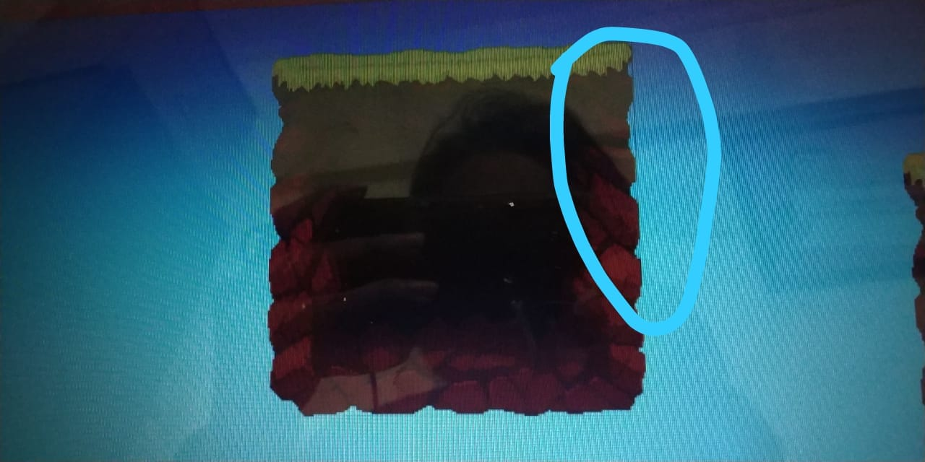

Speculation:

The collider is creating problems as it is capsule and not polygon so I will test it and locate the problem.

Blue line problem! Probably because running out of the image and camera is in solid blue color.

No idea upon the black line problem...Most probably my art problem.